**Assignment-5**

1. Write a C program to swap two numbers using pointer.

Code:

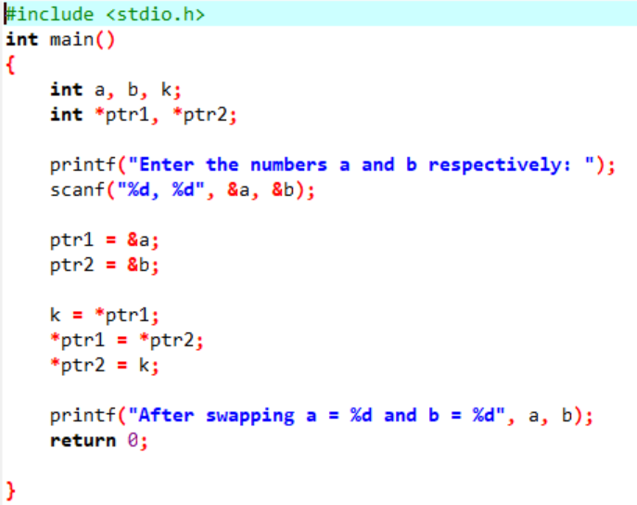

Output:

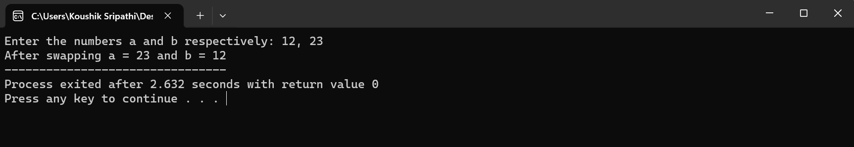

1. Write a C program to search for a particular name from a given list of names using pointer.

Code:

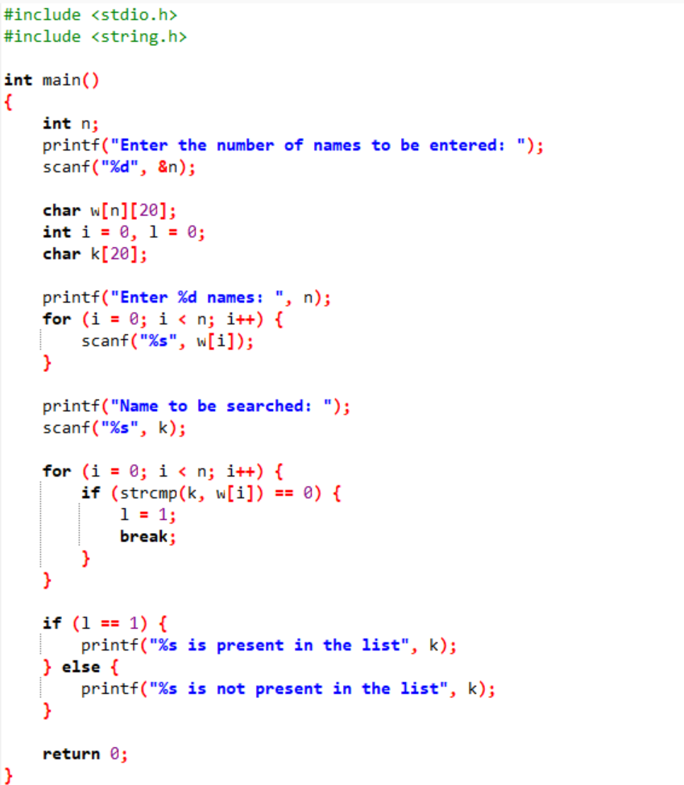

Output:

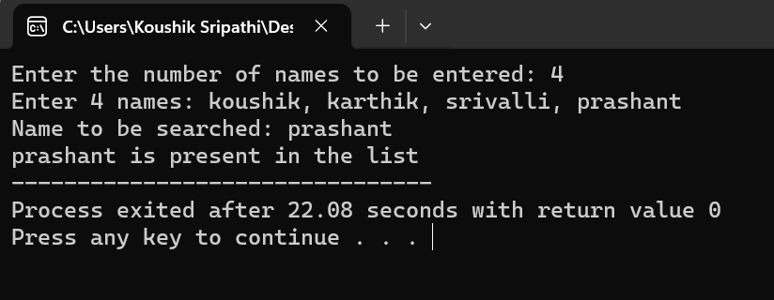

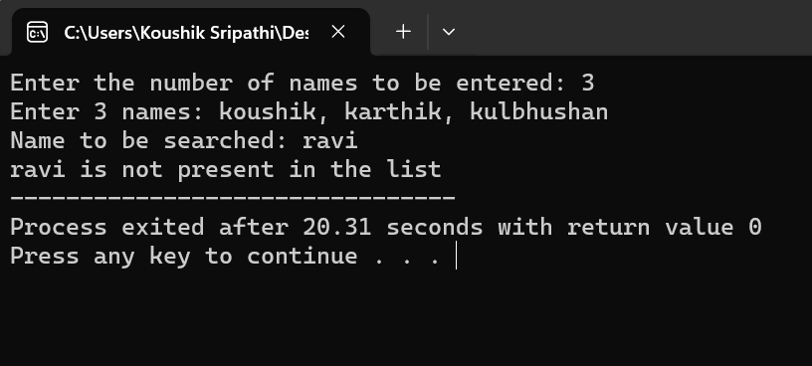

1. Write a C program that reads the name of car, model of a car and its price. Also determine the name of car model that has highest price. Use structure pointer.

Code:

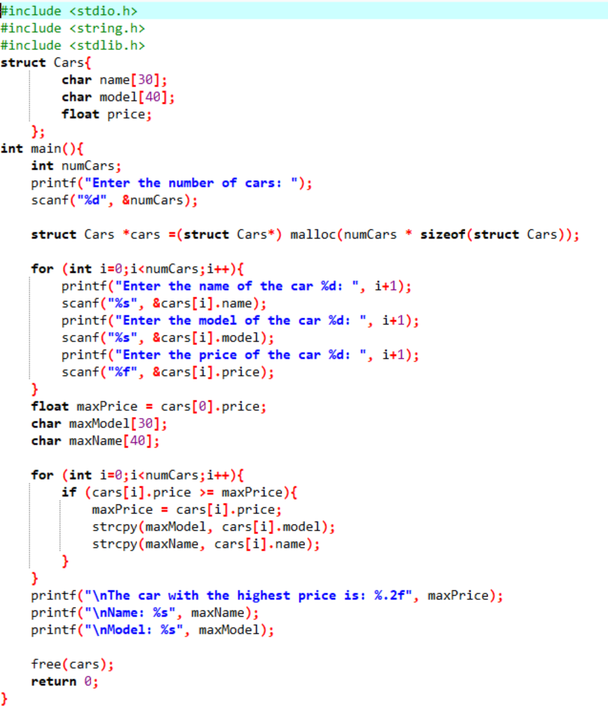

Output:

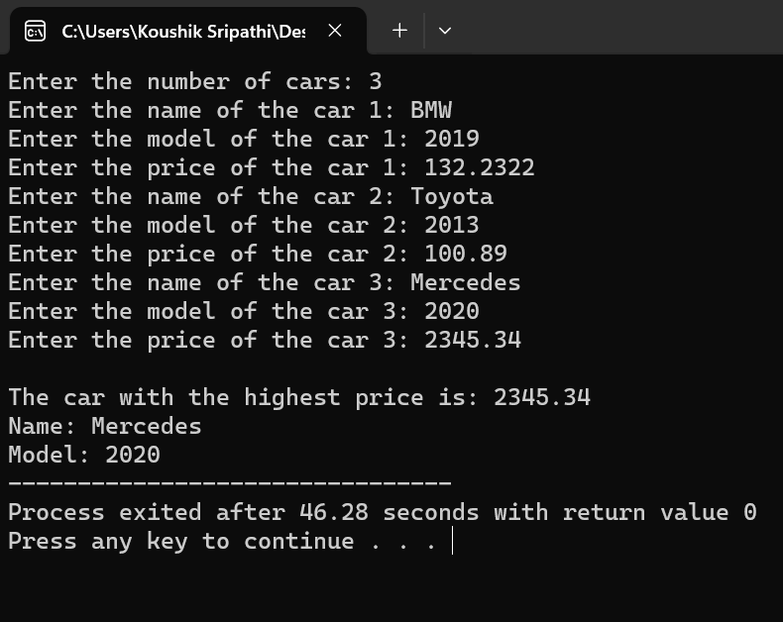

4. Write C program using 2D array for accepting the following details in a student table.

Stud_no, stud_name, mark1, mark2, mark3.

Find the following:

a) Find the total marks of each student and update the student table.

b) Check whether the student is pass or not. (marks >=40 is pass. Else fail). Update this in the table.

c) Find the pass percentage of the class and display.

d) Find out the pass percentage in each subject and display

e) Find the highest in each subject and display.

f) Display the student table according to the rank (highest total being rank 1 and so on...)

Code:

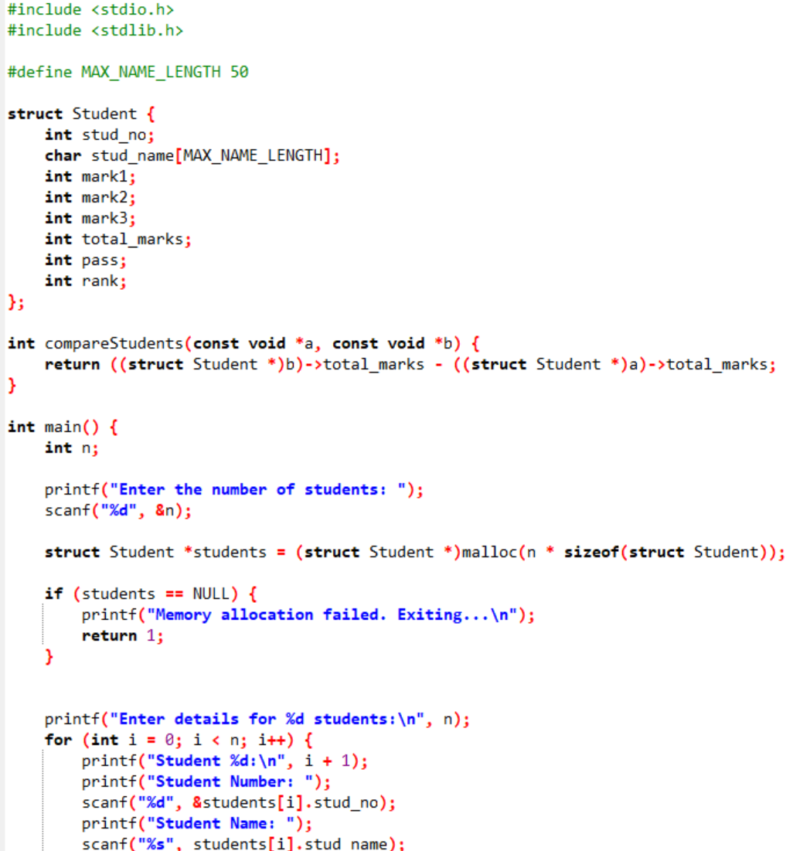

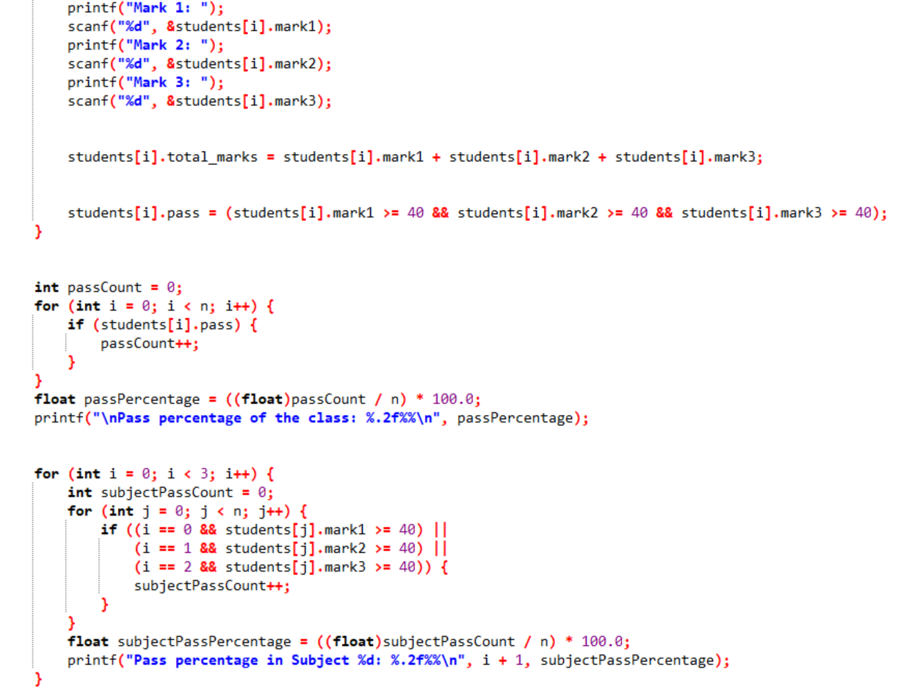

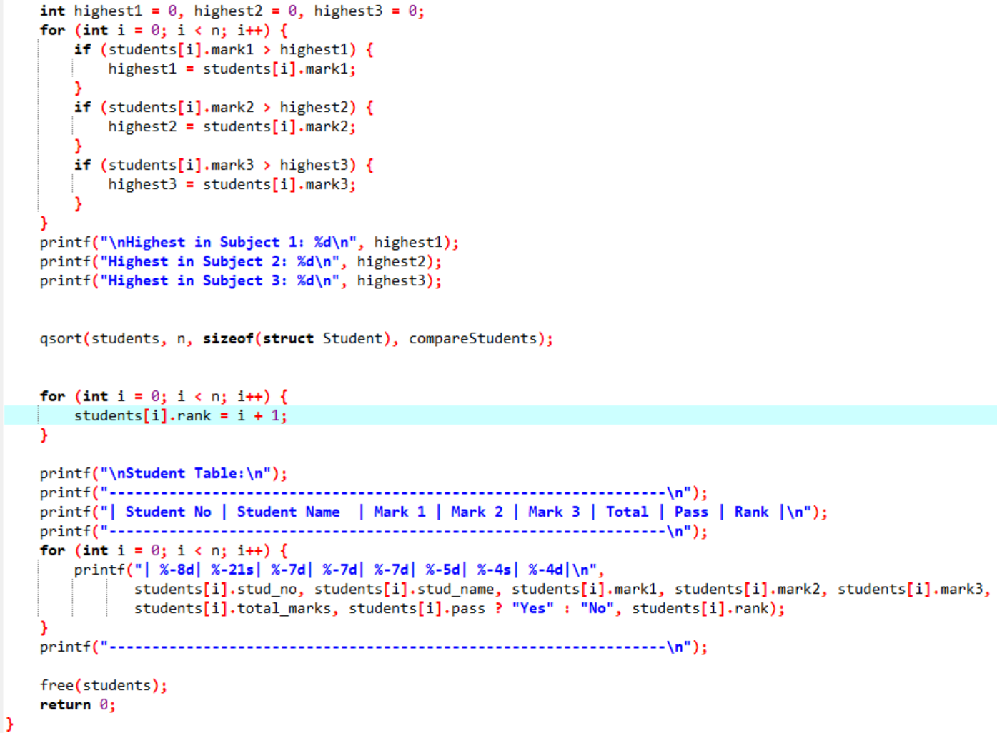

Output:

